**AI Usage Disclosure for Assessments**

Module code: CLDV6211

Assessment Title: POE Part Two Assessment Submission Date: 2025/05/13

**1. Highlight an option:**

I have not used AI in the compilation of my assessment

I have used AI in the compilation of my assessment (please complete the remainder of the form).

**2. AI Tool(s) Used:**

Specify any AI tools, software, or platforms used (e.g., ChatGPT, MidJourney, DALL·E, Adobe Firefly).

List the AI tool(s) here: ChatGPT

**2. Purpose of AI Use:** AI was used for (tick or highlight all that apply):

Idea generation (e.g., brainstorming, mood boards)

Research assistance (e.g., summarizing sources, finding sources)

Writing support (e.g., grammar checking, rewording text)

Other (please specify): My code kept breaking

**Optional additional Notes:** Click or tap here to enter text.

**3. Declaration:**

**Consultation:**

I have followed my navigator’s guidance/guidelines regarding my use of AI in this assessment.

**Original Contribution**

I confirm that AI-generated content has been significantly edited, adapted, or integrated into my own original work. I have not copied and pasted content. Should I be required to supply screenshots of my prompts for this assessment, I will do so.

**Acknowledgment of AI-Generated Content**

If AI-generated content is included (text, images, animations, code, etc.), it has been properly cited and acknowledged within the submission.

**Ethical and Academic Integrity Compliance**

I confirm that AI was used as a support tool and not as a replacement for my creative and critical thinking. The work submitted aligns with the academic integrity policies of the institution. The AI-generated content does not misrepresent my skills or knowledge.

I confirm that I have disclosed my use of AI truthfully and that my submission adheres to academic integrity guidelines.

Student Name: Diya Maharaj

Student Signature: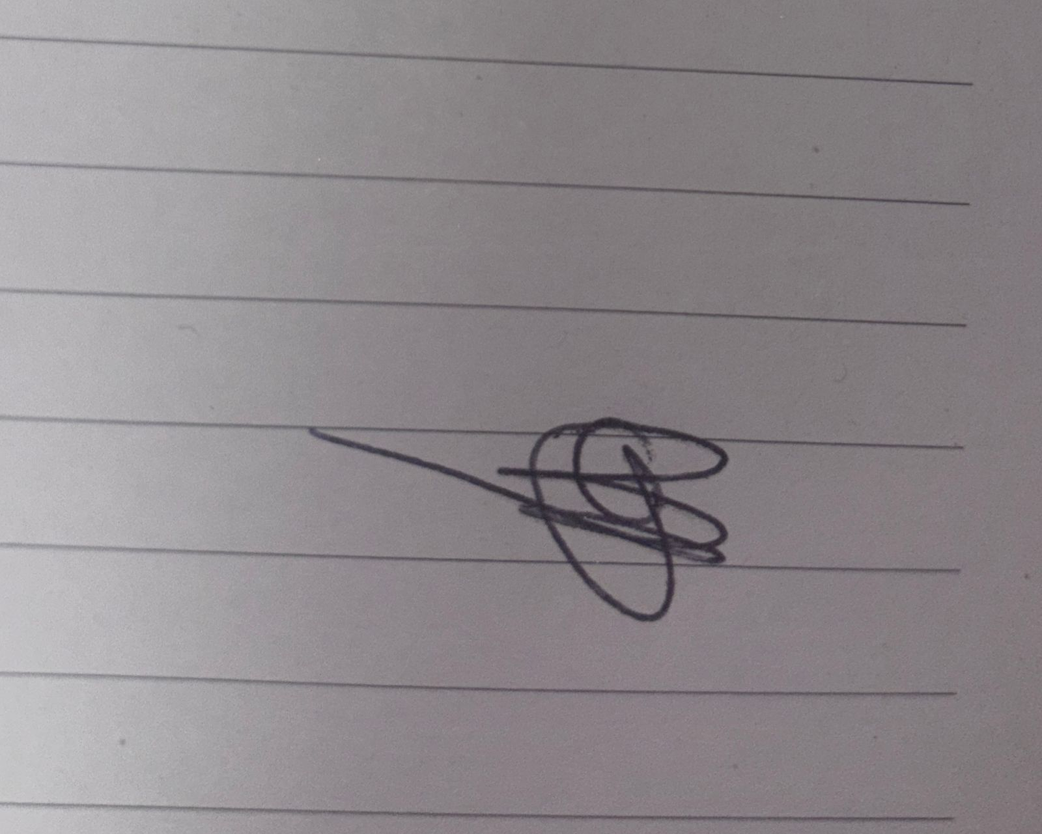

Date: 2025/05/12